Parva House, 335C Wakefield Road, Denby Dale, Huddersfield HD8 8RT Tel: 01484 866368- info@robertshaws.cm/ www.robertshaws.com
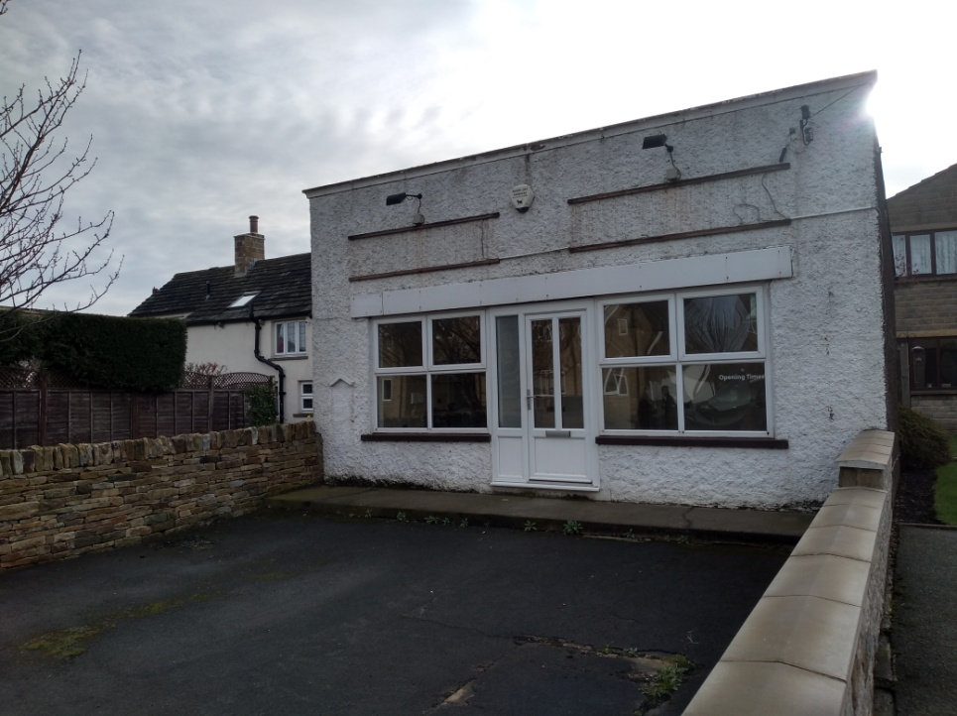
TO LET

Church Street, Emley,
Huddersfield, HD8 9RW.

Rent: £500 per calendar month

Small commercial unit to let with roadside frontage,
off-road parking/tarmaced outdoor space to front
Suitable for a variety of uses, subject to consents
ideal for professional and retail sectors.

Located in the popular rural village of Emley
between the Village Cross and the Church

The Property comprises a single story brick built and rendered building in the heart of Emley Village. The property has previously been used as a hairdressers for over 20 years, although it lends itself to a number of uses. The interior has been Newly Decorated and has UPVC windows and doors. There’s also private parking or outdoor space in front of the property.

Please note the exterior is to be painted by the owner in the spring.

Measurements – Gross- 6.248m X 4.274m
With small areas off for WC – 1.270m X 1.273m – with a low level WC and a wash hand basin. 1.708m X 1.767m with small sink area and plug socket.

Terms
The property is to be let by way of a 6 year lease (contracted out of the security provisions) with a review at year 3. No sub-letting will be allowed. This will be on FRI terms, should alternative terms be required, the rent will be adjusted accordingly. The lease will be outside the security provisions of the Landlord & Tenant Act 1954.

The tenant will be responsible for rates and all other outgoings.

Rent: £500 pcm

Rates Payable: £ 3,800
References will be required.

EPC Band – To be confirmed

For further information contact Robertshaws Chartered Surveyors
01484 866368 info@robertshaws.com www.robertshaws.com

